CSA1519-CLOUD COMPUTING LAB EXERCISES
Jayaharini.J(192371034)
EXP-2 : Property Buying and Rental
Aim
To create a simple Property Buying and Rental System using Zoho Creator, a cloud-based SaaS platform, for managing property listings, customer details, and property booking information.
Procedure
- Log in to Zoho Creator.
- Create a new application named Property Buying and Rental System.
- Create a form named Property Booking.
- Add fields such as Customer Name, Property Name, Booking Type (Buy/Rent), Property Price, Monthly Rent, Rental Months, and Total Amount.
- Create a workflow to calculate the Total Amount based on the booking type (buy or rent).
- Create reports to view all property bookings and customer details.
- Save and publish the application.
- Test the application by entering sample data and verify that the total amount is calculated correctly.

Output:
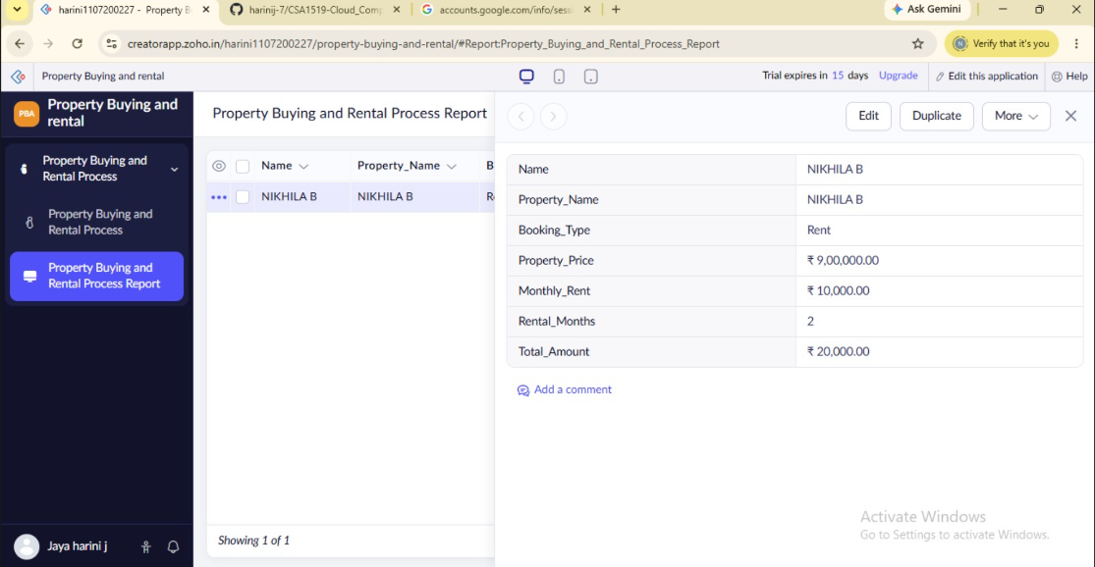
Result
The Property Buying and Rental System was successfully created using Zoho Creator, allowing users to manage property purchases and rentals, calculate the total amount automatically, and store booking details in a cloud-based SaaS application.

